**The**

**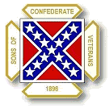**

**Publication of: Private Samuel A. Hughey Camp 1452, Sons of Confederate Veterans and**

**the President Jefferson Davis Chapter, Military Order of the Stars and Bars**

**Volume 38, Issue No. 4 April 2014**

Brig. Gen. James R. Chalmers

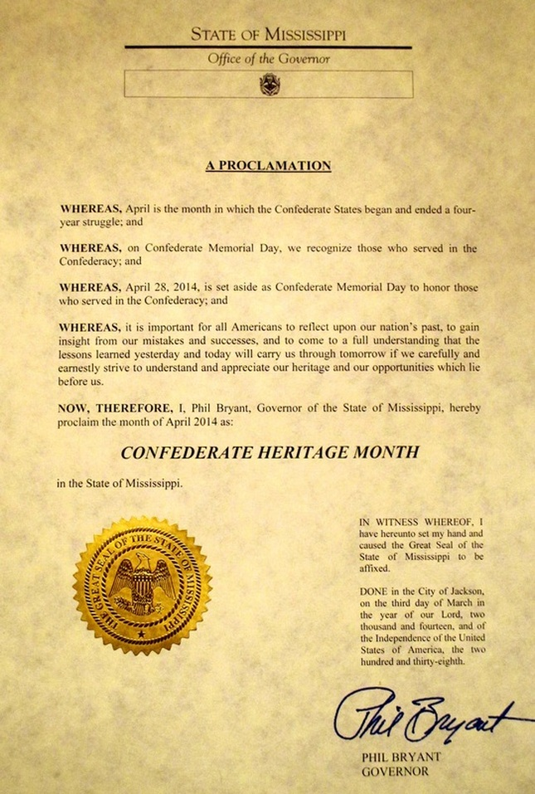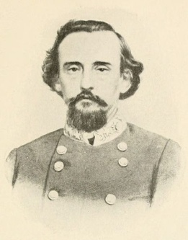Born in Virginia, Chalmers’ family moved to Holly Springs, MS when he was seven. When war was declared in 1861, Chalmers began his military career, serving until the end of the War. He would have legal and political career following the War. Chalmers, his life as soldier and statesman will be the topic of our April 8 camp meeting.

Mr. Tim Harrison, past president of The Desoto County Genealogical Society, will present a program on General Chalmers. Tim has his law degree from The University of Memphis and has had a lifelong interest in the War Between the States.

The meeting will begin at 7 P.M. on April 8 in the Southaven Public Library meeting room.

Members and guests are invited to join in this tribute to General Chalmers. All are welcome.

**EDITOR’S COMMENT:** Program Chairman Randy Hailey has included a special request for members and/or guests. Anyone who would like to speak at one of our meetings or has a speaker in mind, please let him know.

Confederate Heritage Month

And

Confederate Memorial Service

Mississippi Governor and Compatriot Phil Bryant has issued a Proclamation declaring the month of April as **Confederate Heritage Month**. The reason for saying “Compatriot” is we are proud to say that Governor Bryant is a member of the Sons of Confederate Veterans Lowry Rifles Camp in Pearl, MS. We are fortunate to have this man as a Governor and as a Compatriot.

The **Annual Confed-erate Memorial Service** will be held on Sunday, April 27. The service will be in the Old Hernando Memorial Cemetery, 2846 Magnolia Drive, Hernan-do, MS. and will begin at 2:00 P.M.

Rev. Mike Weeks, pastor of the Pleasant Hill Baptist Church, of Pleasant Hill, Ms. will be our guest speaker.

Join members at this important Annual Memo-rial Service honoring our Confederate Dead.

There will be a picnic immediately following at Conger Park across the street from the cemetery. For more information, call Allen Latimer at 662-393-4448 or email bullfrogreb@aol.com.

**For Your Information**:

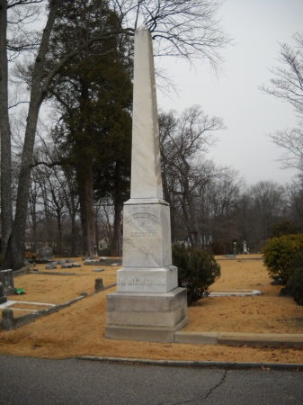This cemetery is the location of the second Confederate monument erected in Mississippi. (The first was dedicated in Amite County in 1871. It was erected on land donated by the Liberty Masonic Lodge in Liberty). Since the state was still under the control of the carpetbaggers and Reconstruction, the monument could not be erected on the court house lawn. Fortunately, an area was donated in the Ready family plot for the erection of the monument where is still stands in honor of our Confederate heroes. The funds for the monument were raised by public donation. Hernando Memorial Cemetery has the largest number of Confederate graves in DeSoto County with 100 marked graves and a mass grave for 60 soldiers.

Confederate Monument - Hernando

Adjutant’s Report

Gentlemen of the South:

The March meeting featured a video on the great victory at Chancellorsville. Generals Lee and Jackson defeated a Federal army, led by General Hooker, twice their size in numbers. It is a battle studied to this day for its military genius. Sadly, the victory cost the South the life of General Jackson. Our thanks to you, Commander Haily, for a wonderful program.

Items of Business:

1. The camp voted to purchase name tags for the meetings. This will help our members and visitors identify those present and create a more Southern and friendly atmosphere.

2. The camp voted to pay the $50.00 fee for a booth at the A'fair in Hernando in May. Please come and participate in this event. A tent is set up and our members have the opportunity to meet and greet the public. It is also an excellent way to spread the truth about the War Between the States and our Confederate Heritage.

3. The camp voted to pay Compatriot Witt $130.00 for the expenses for our guests' cards.

4. On the first Sunday in May ther will be the annual Confederate Memorial Service at the Confederate Cemetery at Ole Miss. Please make every effort to attend and support this service. All of us know the administration at Ole Miss is on occasion hostile to Confederate symbols. Here is your chance to show your respect for our Southern soldiers.

5. The camp voted to donate $150.00 to the M. R. Dye Library in Horn Lake to support their movie in the park. As of this writing, they plan to show "The Horse Soldiers" starring John Wayne.

6. Attention was called to the recent articles in the "Commercial Appeal" dealing with the status of the marker for Forrest Park. Let us hope and pray and support the efforts of our Compatriots in Memphis to see that this marker is restored to its rightful location.

7. A design is being picked for the Mississippi Monument at Shiloh. It is hope it will be dedicated in 2015. Many of you worked long and hard to assist in raising the funds necessary for this monument.

8. The last Sunday in April will be the date of your camp's annual Confederate Memorial Service in Hernando at two in the afternoon. Please atttend to show your respect for our Fallen and to support the efforts of the camp here in DeSoto County. It is always a moving event. We need numbers to show that Southern values are alive and well here.

9. The cemetery on Nail Road is in need of a cleaning. Please contact Commander Hailey if you are available for some work (not real heavy).

At the conclusion of the meeting, those wonderful Ladies of the South provided a most lavish table. We can never thank them enough.

Respectfully,

Allen B. Latimer

Adjutant

Division Information

**Last Notice Regarding**

**Division Convention**

Don’t forget the

**2014 Mississippi Division,**

**Sons of Confederate Veterans State Convention is being held in Corinth Mississippi, June 6-8.**

Registration and convention information have been included in the Division newsletter. In the event you did not see it or did not receive your newsletter, you may contact:

**Larry Mangus - lmangus1941@gmail.com**

**or (H) 662-287-0766 (C) 662-872-9180**.

Camp News

Following are some pictures of camp members at recent activities.

Our thanks to Mrs. Linda McGan for providing these photos for us.



**Lynn Herron**

**and**

**Bill Witt**



**Don**

**Lutz,**

**Allen**

**Latimer,**

**and**

**Cynthia**

**Blalock**

** Grace Jones, Sam McGan, John Jones, and**

**Randy Hailey**

**(Front row) Greg Lutz, Randy Hailey,**

**and Lynn Herron, Zach Griffin**

Memphis to sell Forrest Park Marker If Confederate group won't reclaim it

By Wendi C. Thomas, March 7, 2014, Commercial Appeal

Don’t be surprised if you see an ad like this soon: For sale: One “Forrest Park” 1,000-pound, 10-foot granite marker.

Perfect for Civil War buffs or fans of the Klan’s first grand wizard. The original owner, the Sons of Confederate Veterans paid $9,000. Interested? Call the City of Memphis.

The stone tribute to Confederate general Nathan Bedford Forrest has languished in a Midtown storage shed since January 2013, when Memphis officials plucked it from the park that once bore Forrest’s name. Unless the SCV, which placed the stone without final approval, claims it soon, it’s headed to a city auction block.

“Either you come get your stuff or we’ll consider it surplus,” said George Little, the city’s chief administrative officer.

It’s the latest chapter in the continuing Southern drama, pitting those who still revere the era in which African-Americans were property and those stunned and disgusted that this debate continues. Recent developments include the marker’s removal in January 2013; the Memphis City Council’s decision to rename of three Confederate-themed city parks last February, which freed these green spaces from names that reflected fondly on an era when 63 percent of Memphians would have been enslaved; a March 2013 rally Downtown by the KKK to protest said name changes, for which the city and county spent $175,585 on public safety; and a new state law rushed through by Republicans (the party of less government intervention and more local control) last April, that strips cities of the authority to rename any war-themed parks.

The next showdown will come by June when the city plans to vacate the storage building next to Overton Park where the marker sits.

“We are in the process of discussions to locate the Eggleston photo museum on that parcel of land, as part of a longer term arrangement with the Overton Park Conservancy.” Little said. The goal is “to get as much of that park back to the natural state as possible.”

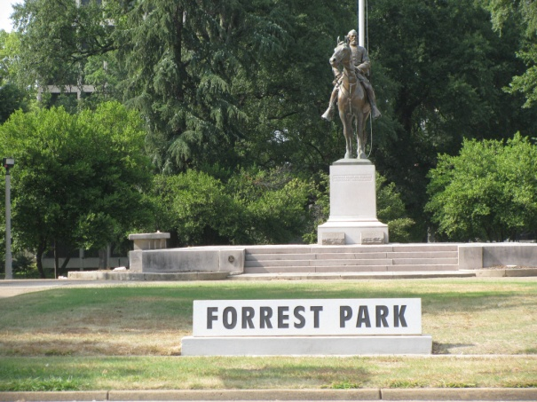“We don’t want any-thing to hap-pen to it,” he said, but “we’re not taking it with us ... If someone wants it as a yard marker, they’ll be welcome to it.”

More than once, the city has asked the SCV to take the marker, but spokesman Lee Millar wants city officials to put it back where they found it.

“We did NOT refuse its return,” Millar said by email. “We stated where it should be returned to: namely, its rightful place in Forrest Park.”

There’s only one problem with Millar’s demand, and it’s a big one: “There isn’t a Forrest Park to put it back in,” Little said.

The park at Union and Manassas near Downtown still features an equestrian statue of the slave trader and Forrest’s remains. But it’s called Health Sciences Park, in a nod to its location next to the medical school and the city’s aspirations to be known as a biomedical center.

Little understands the SCV’s motivations. “If they took the marker back, it might affect their case.”

That’s right: This is still the land of the free and the home of the litigious: The SCV has sued the city for the “theft” of the marker and parks’ renaming. Perhaps a detente could come through the award-winning movie based on an 1853 slave memoir. “If anyone wonders why they might find that marker offensive, go see ’12 Years a Slave' and then come talk about it,” Little said.

\_\_\_\_\_\_\_\_\_\_\_\_\_\_\_\_\_\_\_\_\_\_\_\_\_\_\_\_\_\_\_\_\_\_\_\_\_\_\_\_\_\_\_\_\_\_

This is why we have to continue the fight...this is why our litigation cost continues to climb.....this is why we need your help......

Citizens To Save Our Parks, P.O. Box 241875, Memphis, TN 38124.

H.L. Hunley,

First Submarine to sink an enemy ship

**February 17 marked the 150th Anniversary of the H.L. Hunley and its mission against the federal blockade ship Housatonic off Charleston.**

**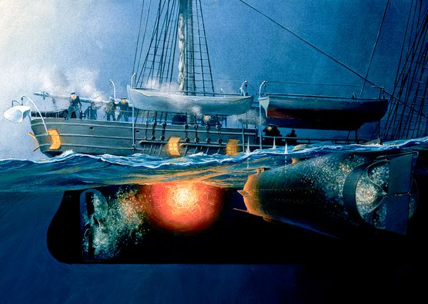**

**(**http://news.nationalgeographic.com/n...07\_600x450.jpg**)**

**The Hunley: Zeroing in on what caused Civil War submarine's sinking**

By **Phil Gast**, CNN Sat February 15, 2014

**(CNN)** -- Born and built amid gray-cloaked secrecy during the American Civil War, the H.L. Hunley -- the first submarine to sink an enemy ship -- has held tight to its murky mysteries.

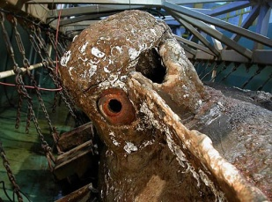The 150th anniversary of the Hunley's daring and dangerous raid will be marked this weekend and Monday, but the overarching question remains: What caused the submarine and its eight-member crew to slip to the bottom of the sea on the moonlit evening of February 17, 1864, after it signaled to shore a success that changed naval warfare.

The Hunley, housed at a laboratory in North Charleston, South Carolina, has yielded its secrets slowly and sparingly, even to researchers armed with the latest in technology.

Was the loss of the Hunley the result of the torpedo's detonation? An unsecured hatch? Or perhaps a lucky enemy shot that blasted a hole in the Confederate vessel's viewing port?

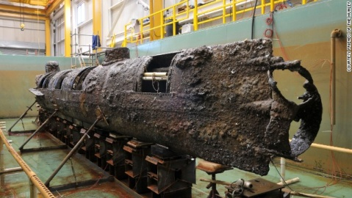And why were the crew's remarkably preserved remains found at their stations, rather than jammed together near an escape hatch?

These and other questions continue to enthrall scientists and historians as the sesqui-centennial is observ-ed with tours and events in the Charleston area.

**Unmasking the Hunley's secrets**

There is hope that some additional clues may emerge soon.

The Hunley Project, a consortium of researchers, scientists and state and federal agencies, this year begins a conservation phase that might add an important piece to the puzzle of what happened to the submarine. A chemical bath will peel away the final layer of sediment that covers the exterior of the well-constructed hull and the Hunley's interior.

**What we know about the doomed crew**

"You are going to be blown away. You are going to look at the face of the submarine for the first time," says Paul Mardikian, the project's senior conservator.

Already, the Hunley impresses visitors who gaze down to a 90,000-gallon freshwater conservation tank. Dive planes and remnants of other submarine components, including ballast tanks, are evidence of the innovation and care of the sub's designers and builders.

Patrons at the Warren Lasch Conservation Center also see the encrusted sediment, known as concretion -- a mix of sand and remains of sea life -- that Mardikian likens to a "black box."

By removing the material, he says, researchers will be able to do more precise analysis of holes in the hull and its condition, the Hunley's speed and performance in the

Atlantic Ocean and whether gunfire from the USS Housatonic, its target, contributed to the submarine's demise.

"If the submarine was hit by a bullet, you should be able to see that in the metal," says the conservator.

By combining new findings with previous study, including that of the remains of the crew, experts believe they will be able to tell the complete story of what happened to the Hunley, which was brought to the surface amid much fanfare in August 2000.

"I am confident this is all going to fall into place," says Mardikian.

But don't be surprised if everything falling into place won't result in a "smoking gun" that points to a single cause.

"There may be several things (factors) happening at the same time," according to Mardikian.

Archaeologist Michael Scafuri says the team is trying to ascertain the truth of what happened that chilly night a few miles offshore from Charleston. But there are no guarantees.

"It is like detective work -- with a really cold case."

**'Curious' submarine a danger to its crews, too**

The cold case begins in Mobile, Alabama, where the Hunley was built for the Confederate government.

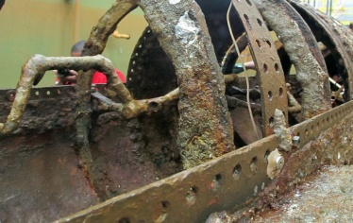The 40-foot vessel, described as "curious" looking and resembling a whale, had watertight hatches, two short conning towers, sea cocks, pumps and ballast tanks.

But there were shortcomings. There was constant concern about a sufficient oxygen supply for the crew, which limited its dive time. The captain had a difficult time monitoring certain movements.

The Hunley was dependent on the crew hand-turning a crank to power the single propeller. Batteries and a steam-powered engine proved impractical for the submersible.

"We don't know how real well the submarine functioned," says Scafuri. "This is a case where they settled on what would work. That was hand power."

Confederate officials ordered the Hunley to Charleston, where it and other ships prepared to challenge a blockade of the harbor. The Federal Navy had deprived the Southern city of vital military supplies.

The Union fleet was well aware of the Hunley's danger -- to its own occupants.

Five members of the first crew died in August 1863 when it accidentally dived while its hatches apparently were open. The second crew's eight members succumbed in October when the Hunley failed to return to the surface.

The Confederate commander of Charleston, concerned about the loss of life and the expense of recovering the Hunley, ordered that any attack be made on the surface. Still, the vessel would be mostly under the water line during an attack.

Still, those who volunteered for the mission against the 205-foot USS Housatonic must have been well aware of the perils when approached by Hunley skipper Lt. George Dixon.

"This took some serious bravery here. I wouldn't want to go in there," says forensic genealogist Linda Abrams, who has conducted extensive research on the Hunley crew. "They know some other people had drowned in it. They had to have some faith in Dixon."

Dixon and his courageous crew, which included four European-born men, would target the Housatonic, the closest blockade ship.

Dixon routinely kept a worn good-luck charm in his pocket: A gold coin that was bent when he was wounded nearly two years before at the Battle of Shiloh in Tennessee.

In 2001, the shiny talisman was found in the laboratory, along with Dixon's presumed remains. Only one crew member has been positively identified through DNA tests.

**Menacing object approaches wary ship**

On a chilly February evening 150 years ago, the Hunley set out from Breach Inlet, which separates Sullivan's Island and what is now called the Isle of Palms. The vessel churned toward the Housatonic, about 4 miles away, at an estimated speed of 2 to 4 knots.

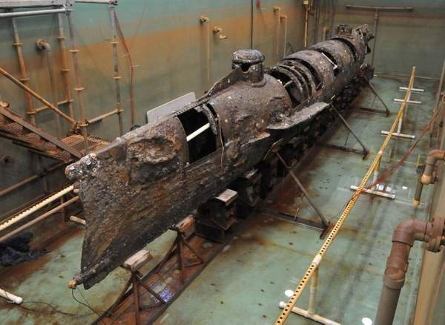One of the crew members would have been in charge of bellows, providing sufficient air to breathe when the hatches were closed.

Friends of the Hunley, a nonprofit group establish-ed by South Carolina's Hunley Commission, provides a history of the mission on its website.

"While the cold bit through the lookout's coat ... men poured sweat over hand cranks that powered a spinning propeller while their captain manned the dive planes -- steering man, iron, anxiety and raw courage towards its final destination."

"A lookout aboard the Union Navy's largest ship was tired, cold -- but restless. Talk of a Confederate secret weapon was in and out of his thoughts. Suddenly he spotted something move in the chilly waters. A porpoise? There were certainly a lot of them around. But something about this one didn't seem right."

Alarms went out on the Housatonic, which carried 12 guns.

The Hunley was too close and low to be hit by artillery fire, so crew and officers of the Union ship fired small arms, rifles and even a shotgun at the approaching menace.

Once in place, a submarine crew member managed to pull the lanyard for the 135-pound torpedo, attached to a 16-foot spar that was still connected to the Hunley's bow.

The Housatonic sank within minutes.

Five members of the Union vessel died; 150 others were rescued.

**All kinds of scenarios for loss of Hunley**

A Union sailor who climbed to the Housatonic's rigging and a Confederate observer on the shore reported seeing a blue light emanating from the Hunley, signaling mission accomplished.

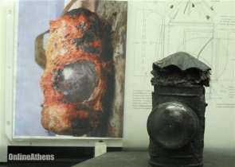"That indicates someone was conscious after the sinking of the Housatonic," says Robert Neyland, head of underwater archaeology for the Naval History and Heritage Command and former director of the Hunley Project.

But researchers have been unable to precisely pinpoint the source of the light -- whether it came from a lantern or pyrotechnic device that sent out various signal colors. And it's possible the light came from Union rescuers.

Experts looked at the Hunley's lantern, but found no evidence of blue glass.

"I think it was just Dixon's flashlight, to be honest," says Mardikian, the conservator.

One scenario holds that the Hunley was swamped by or struck by a Union vessel. Or that it plunged to the sea floor to avoid detection, and never made it back up. A latch on the forward conning tower was found to be not properly locked.

In January 2013, Hunley scientists, who work for the Clemson University Restoration Institute, reported a significant discovery.

"Until now, the conventional wisdom has been the Hunley would ram the spar torpedo into her target and then back away, causing the torpedo to slip off the spar," they said in a statement.

Instead, research showed the submarine was less than 20 feet from her torpedo when it exploded.

"There is overwhelming evidence to indicate this was not a suicide mission. The crew no doubt knew the dangers facing them, but still, they hoped to make it back home. They must have believed this was a safe enough distance to escape any harm," says South Carolina Lt. Gov. Glenn McConnell, head of the Hunley Commission.

It's possible that the force of the explosion incapacitated the crew, eventually causing the sub to slide down into the chilly depths. Even a small hole or holes could have allowed water to seep or pour in.

"Everything we have tried to explain (as to) how the submarine worked, we were naïve in our approach," says Mardikian.

Researchers at the lab, while excavating the sub's interior silt that held the the human remains, found the eight Hunley crew members were still at or near their stations, despite an unsealed forward hatch.

"We don't see evidence of anyone trying to get out of the submarine. It could have been something catastrophic or they died with a certain amount of resignation," Neyland says.

Detailed examinations of the well-preserved remains of the crew looked for the tiniest of fractures or evidence of concussion. "We did not find any unhealed injuries to their skeletons," says Scafuri, the Hunley Project archeologist.

The team is still gathering and analyzing data on the physics and effects of the detonation on the Hunley and its doomed crew, he says. It also continues to analyze the source of holes in the hull, possibly from battle damage or exposure to currents and underwater conditions.

**Ongoing efforts to learn more about sub, crew**

In 1995, the Hunley was finally located by a group led by author Clive Cussler. It rested in several feet of silt, largely protected from strong currents and the most corrosive effects of saltwater. The environment, mostly free of oxygen, left the skeletal remains and artifacts in amazing condition.

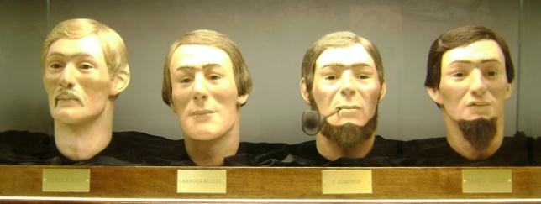The submarine was brought to the surface five years later and was quickly placed back in protective water at the Lasch laboratory.

The federal and South Carolina governments have contributed an estimated $9 million or so between them on the recovery, lab and research. The Hunley, considered a spoil of war, is the property of the U.S. Navy.

About 40,000 visitors a year marvel at the Hunley, see exhibits and peer at facial reconstructions of the crew members.

Researchers found personal artifacts, including a wallet, watch, bandana, matchsticks and remains of tobacco pipes.

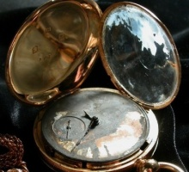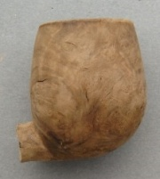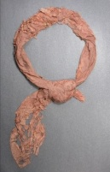

One mystery was answered relatively early in the excavation and conservation process.

"They didn't know whether these guys had escaped and tried to swim to shore," genealogist Abrams says of the Hunley crew. "Or whether they had been taken captive. There was no concrete knowledge that they were still inside."

Inside the sub, scientists found human hair, complete skeletons and skulls of eight people -- debunking one part of the legend that held that nine men were on board.

Abrams has spent years trying to learn more about the crew. She has learned a great deal, but is hampered by the fact that only one is known to have married and have children. And there are no known photographs of any.

Kellen Correia, executive director of Friends of the Hunley, says she expects a permanent museum to be built around the end of the decade, with expanded days of operation, instead of the current weekends…

"I love that it engages people," she says. "You know why the Titanic went down. With this, you don't have that known factor."

**http://www.cnn.com/2014/02/14/travel/civil-war-submarine-hunley/index.html**

csa_starbar.gif

To learn more about the Hunley, her history and recovery, visit **http://www.hunley.org/**

csa_starbar.gif

**CONTACTS**

**The *Southern Comfort*** IS A MONTHLY PUBLICATION OF THE **Pvt. SAMUEL A. Hughey Camp #1452, SONS OF CONFEDERATE VETERANS AND PRESIDENT JEFFERSON DAVIS CHAPTER, MILITARY ORDER OF THE STARS AND BARS., DeSOTO COUNTY , MS**.

***PERMISSION IS GRANTED TO REPRINT ANY ARTICLE.***

**Camp Commander john jones**

**5853 Iroquois Dr., Horn Lake, MS 38637**

**Camp Adjutant Allen Latimer**

**5205 Horn Lake Rd, Horn Lake, MS 38637**

**(662)393‑4448 E‑ mail: bullfrogreb@att.net**

**Camp Chaplain Greg Lutz**

**5221 Brenda Cove, Horn Lake, MS 38637**

**(662) 781-1749 E- mail: olerebdixie@live.com**

**EDITOR JOHN L. ECHOLS**

**8477 Southaven Circle West, Southaven, MS 38671**

**(662) 393‑2803 E‑ mail: soucom@att.net**

**csa_starbar.gif**

# This David took on mighty ship in 1863

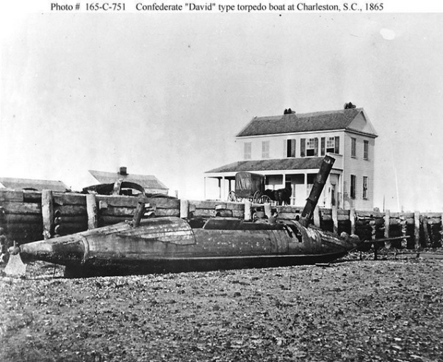

[The David was a low-profile torpedo bost designed to take out blockade ships. This one, photographed after the war, may have been the one that attacked the USS New Ironsides.]

The Union sailors spotted the curious little boat shortly after 9 o’clock, just as it was closing in on the starboard beam of their ship.

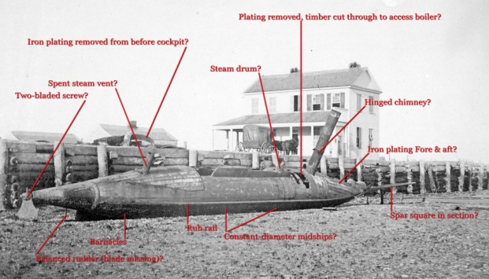It came from the east, which confused the men. Either this strange craft was a long way from home or it had come out of Charleston and somehow managed to slip through the South Atlantic Blockading Squadron. The puzzled crew tried to hail the little boat four times, but it kept coming — on a collision course for the flank of the USS New Ironsides.

The boat, which looked like a whale’s flank — albeit with a smokestack — showed no signs of replying to the crew’s hails, so the sailors opened fire with their muskets.

The boat retaliated almost immediately with small arms fire, one shot hitting the officer of the deck, Ensign C.W. Howard, who would later die. The New Ironsides crew continued to fire on the boat, but it kept coming.

When the strange craft got within 20 feet of the New Ironsides, a great explosion rocked the mighty warship off its keel.

They were under attack.

On Oct. 5, 1863, four Confederate sailors in a small torpedo boat took on one of the U.S. Navy’s mightiest warships outside Charleston Harbor. It was one of the first attacks of its kind in history, and it accomplished two things. It gave a city struggling under siege a glimmer of hope, and it gave U.S. Navy officials heartburn.

“Among the many inventions with which I am familiar, I have seen none which have acted so perfectly at first trial,” Rear Admiral John A. Dahlgren, commander of the South Atlantic Blockading Squadron, wrote after the incident.

The David had slipped out of Charleston Harbor just after dark that evening and found the New Ironsides at anchor off Morris Island. The crew waited for the tide to turn before aiming its spar torpedo at the ship’s side.

The torpedo boat was an oddity, although it was just one of several similar vessels under construction in Charleston. The name of these boats may have been taken from one of the builders, but most people ascribed it to the Biblical tale of the man who took down the giant Goliath. It was an apt description.

The David was about 50 feet long and carried a crew of four men in an open cockpit. The cigar-shaped boat ran on steam and its jet black smokestack was the only thing that stood more than two feet above the waterline. The engine even burned anthracite coal, so that it belched clear smoke.

The David’s target that night was not coincidental. The 230-foot New Ironsides had led the attacks on Fort Sumter for most of the year, and the Confederates were desperate to take out the ship they called “Ironsides” with a mix of disdain and grudging respect. The New Ironsides carried more than a dozen big guns, was powered by sail and steam, and had metal sheeting over its hull to protect it from enemy fire.

But it could not easily fend off a point-blank attack.

The explosion from the David’s contact mine — which held 70 pounds of powder — rocked the New Ironsides to port and rattled its iron skin, but did not sink it.

The blast also threw a great deal of water into the air, some of which fell into the David’s low smokestack, extinguishing the fire for the steam engine.

Suddenly, the David was adrift and defenseless.

The captain — Lt. William T. Glassell — decided they must abandon ship. If a Navy ship found them, they were doomed. He ordered his crew into the cold, inky water.

The David’s engineer, J.H. Tombs, did not swim far before he decided that he’d rather take his chances on the crippled boat. He found another crewman, J.W. Cannon, clinging to the boat’s smokestack. Cannon could not swim. The two men worked together until finally they restarted the fire and limped back to Charleston.

Gen. P.G.T. Beauregard was ecstatic. The next day he wrote in his report that Glassell had “gallantly attempted to blow up the Ironsides with the small cigar torpedo boat.”

“Explosion occurred at proper time, but either charge was too small or torpedo too near surface,” Beauregard wrote. “Damage thus far not apparent. Lieutenant Glassell and 1 man were captured; other 2 returned safely with boat. Commotion on board the Ironsides reported very great.”

Glassell and the other crewman, James Sullivan, would not divulge information about their stealth boat. And the U.S. Navy would not talk about the true extent of the damage to the New Ironsides.

“(T)he damage done by the torpedo was much more serious than first appeared,” Dahlgren wrote a month later. “I need not urge the importance of keeping the facts from publicity.”

Eventually, the New Ironsides limped off over the horizon for repairs, and Tombs and the David became quite popular in Charleston.

But the tiny torpedo boat would not attack again until the following spring, one month after its more famous cousin — the submarine H.L. Hunley — struck another blow against the blockade.

But the David had sent the U.S. Navy a loud message. The era of the torpedo boat had arrived.

**http://www.postandcourier.com/article/20131005/PC1610/131009670/1009/this-david-took-on-mighty-ship-in-1863&source=RSS**

csa_starbar.gif

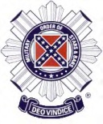MILITARY ORDER OF

THE STARS AND BARS

Founded: 30 August 1938

The Military Order of the Stars and Bars International Headquarters

PO Box 1700

White House, Tennessee 37188-1700

Membership in the MOS&B is limited to lineal or collateral male descendants of officers who served honorably in the Confederate Armed Forces and male descendants of elected and appointed civilian officials of the Confederate States; the national Confederate Government; and the Five Civilized Tribes which allied with the Confederacy. All members must be at least twelve years old. Ancestral documentation must accompany all applications for membership.

Mission: The members of the MOS&B bear an extra responsibility to their Confederate heritage. We strive to preserve the special place in our Southern history for the Confederate officers and civil leaders.

Please note: the name "Military Order of the Stars" and the organization's insignia are registered trademarks and may not be used without the express permission of the organization.

**Website: http://www.militaryorderofthestarsandbars.org/**

The Military Order of the Stars and Bars is a fraternal organization for documented descendants of men who served as commissioned officers in the armed forces of the Confederate States of America or who are descended from members of the Confederate Congress, or any elected or appointed member of the Executive Branch of the Confederate Government. Its headquarters is in White House, Tennessee. Members may join local Chapters as well as State Societies or be a national At-Large Member.

Founded in 1938 in Columbia, South Carolina, during the Great Depression, it is the only active heritage organization created by Confederate veterans. The first meeting was convened by 17 former Confederate officers, with 47 male descendants of Confederate officers in attendance. They voted to begin a new CSA veterans society, with a commitment to hold annual meetings, and chose the name of the "Order of the Stars & Bars". The OSB was unique in its understanding that as the original Confederate officers died, their male descendants had to carry on the purposes of the Order.

In 1976 the organization changed its name to "The Military Order of the Stars & Bars" at the 39th General Convention held in Memphis, Tennessee. They adopted the Confederate battle flag (the square "Southern Cross" incorporated into the second and third National Flags of the Confederate States of America, not to be confused with the "Stars and Bars" adopted as the first national flag) as the official insignia of the Order. The leader would be called the Commander General of the Military Order of the Stars and Bars.

Today the fraternal Military Order of the Stars and Bars is a non-profit 501(c) 3, non-political educational, historical, patriotic, and heritage group that is dedicated to preserving Southern history. It has added programs to recognize outstanding contributions in the fields of history, as well as the fine arts that emphasize Southern culture.

It offers college scholarships and awards for the study and communication of Confederate and American history. It awards literary prizes to authors and publishing houses, and recognizes journalists who practice ethical and fair reporting of local and Southern history. It erects monuments to the memory of the CSA soldiers. The organization emphasizes American patriotism and the honoring of all American military veterans. The Order emphasizes family and tradition, and encourages its membership to preserve their family's Confederate history for posterity.

Today the Military Order of the Stars and Bars continues its dedication to the preservation of Southern history which it deems accurate.

Chapters Information

The next meeting of the **LT. Gen N.B. Forrest Chapter 100** will be May 10, 2014 at the Lee County Library in Tupelo   10:00 AM

-----------

Plans are being made to reactivate the President Jefferson Davis Chapter, MOSB in DeSoto County. Commander Randy Hailey is leading up this reactivation. Past members of the MOSB or those interested in joining are encouraged to contact Randy. This is very important and all support is needed.

[Copyright 2012 Sun\_Herald. All rights reserved. This material may not be published, broadcast, rewritten or redistributed.](http://www.www.sunherald.com/terms-of-service)

IRREPRESIBLES

**HONORING THOSE MEN WHO SERVED IN HORN LAKE'S COMPANY A, 9TH MISSISSIPPI INFANTRY SERVING WITH HONOR WHILE WEARING THE GRAY. IN THEIR HONOR WE RECOGNIZE THOSE WHOSE FINANCIAL CONTRIBUTIONS HAVE EXHIBITED THAT SAME SPIRIT AND HONOR.**

**Honorable Darrell Britt, Southaven**

**Honorable George M. Church, Meridian**

**Dr. Christopher Cummins, Ripley, MS**

**Commander Louis Foley, Newton, MS**

**Admiral Robert Fulton (Retd), Memphis**

**Honorable Lynn Herron, Southaven**

**Honorable Ron Hocking, Fremont, NE**

**Sgt. Tommy Hughes, Hernando, MS**

**Honorable C. C. Hoover, Olive Branch, MS**

**Mrs. Robert Kuhn, Robinsonville, MS**

**Mrs. Anne McAnally, Hernando, MS**

csa_starbar.gif

# **Confederate Revolving Cannon**

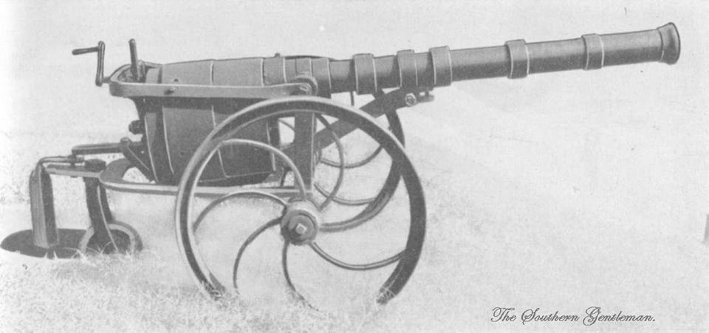

Henry Clay Pate was a former attorney who, during the U.S. Civil War, organized a mounted company that was called Pate's Rangers or the Petersburg Rangers. The innovative Pate designed the revolving cannon, which he had cast at the Petersburg foundry in Petersburg, Va. This cannon was then made available to Pate's unit.

The cannon saw use in the siege of Petersburg, Va. It was captured by Union troops at Danville, Va, on April 27, 1865. While innovative, the weapon did not play a significant role on the battlefield. After its capture, the cannon was sent to the Ordnance Laboratory, United States Military Academy, West Point, New York.

Design and Features

The revolving cannon was designed with the goal of increasing the fire rate of a cannon. The design was somewhat similar to that of a revolving pistol of the time, consisting of a cylinder which contained the rounds to be fired, with the rotation of the cylinder used to bring the round into position at the breech of a single barrel. The barrel had a two inch bore, and the cylinder held five rounds.

The cylinders of the revolving cannon were fired using percussion caps. The cap was struck by a large spring-actuated striker.

The cannon employed a screw mechanism which would push the cylinder forward when it was in position. This reduced the gap between the cylinder and the barrel, which significantly reduced gas leakage during firing.

A lever attached to a ratcheting mechanism was used to rotate the cylinder. A spring loaded dog would slip into recesses in the cylinder, holding it in the correct position for firing.

Note: William Austin Leyden of the 9th Battalion Georgia Artillery had a patent for a revolving cannon too.

**http://civilwartalk.com/threads/confederate-revolving-cannon.95302/**

csa_starbar.gif

**And when my time in Dixie ends**

**A last request of all my friends-**

**Place my ashes in a cannon,**

**Make sure it's pointed North**

**Sing Dixie one last time for me**

**And fire the Damn thing off ---**

**David Tatum Jr**

csa_starbar.gif

"Perfectly satisfied to die:" Capt. Absolom Dantzler and the Battle of Corinth

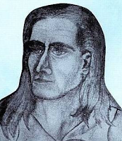Absolom Frederick Dantzler was born in 1824 in Greene County, Mississippi, the son of a wealthy farmer named John Lewis Dantzler. Absolom's younger brother, born on New Year's Eve in 1833, was Lorenzo Dantzler, who would later become a successful lumber merchant in Moss Point. In 1847, Absolom graduated from Centenary College, then located in Jackson, Louisiana, and moved to Natchez. In 1849, he caught the California gold fever. Heading west with a large company organized by Major Walter H. Harvey, a West Point graduate and an experienced miner, the "manly band," as the Holmes County Mining Company was described by a Texas newspaper, was formed as a military organization. Arriving in the Sacramento Valley after an arduous journey, Dantzler wrote to a brother in Natchez that he was confident of success. "I think I am now in the high way to fortune," he said, "and will reap a rich reward for all the troubles, dangers, and hardships that I have passed through in geting [sic] here."

By 1855, he was back in Natchez, apparently never reaping the fortune he envisioned. Major Harvey, meanwhile, was charged with the murder of "Big Jim" Savage, known as the "Blonde King of the Indians" and for "discovering" the Yosemite Valley. Savage (left), on behalf of the local Indian tribes, challenged Harvey's company (likely including Dantzler) when they attempted to move onto Indian lands in the newly created Tulare County, where Harvey had been named county judge in a rigged election. In the dispute, Harvey, who was "high-strung and absolutely fearless," shot Savage four times. He was ultimately found not guilty and continued to serve as the county judge. Harvey never returned from California, and died in Los Angeles in 1861.

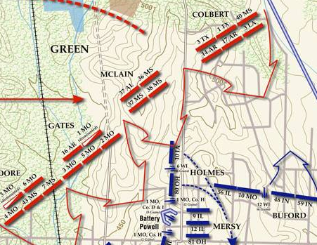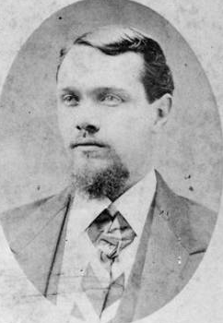Back in Mississippi, Absolom Dantzler flirted with the "Know-Nothing" party and then moved to Jasper County, where he entered the political arena. In 1859, he was elected to represent Jasper County in the Mississippi Legislature. It probably helped that he married well, but the big issue in the election (despite such topics as slavery and states' rights) was whether or not to move the county seat from Paulding, located in the eastern side of the county, to the center of the county. When Dantzler (right) threw his support behind those who wanted to hold a separate referendum on the issue, he narrowly won the seat in a hotly contested election. Dantzler, who supported secession, continued to represent Jasper County in the Legislature into the war years despite the fact that he joined the Confederate army in April 1862.

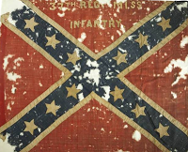With the onset of the Civil War, thousands of volunteers rush-ed to enlist in the Confederate cause. Many of Mississippi’s

early regiments went to Virginia and Kentucky where the fighting seemed most eminent. Other regiments, however, were not formed until after the war had been underway for some time. Such is the case with the 37th Mississippi Infantry. Formed on April 28, 1862, the 37th Mississippi was mustered into service at Columbus. Among the companies which comprised the regiment was Co. K, known as the “Jasper Avengers.” Elected as captain was Absolom Dantzler. No doubt his experience with the mining expedition in California and his political connections played a major role in his selection. Once formed, the 37th Mississippi became part of Col. John D. Martin’s brigade, along with the 36th and 38th Mississippi, and in September moved with Sterling Price to Iuka to cooperate with Braxton Bragg’s invasion of Kentucky. Alerted that Price was in Iuka, Gen. Ulysses S. Grant tried to catch the Confederates in a pincer. During the battle of Iuka on September 19, 1862, Price’s men fought one of the attacking Union columns, commanded by William S. Rosecrans, south of town. Although the 37th Mississippi was not engaged until late in the day and was separated from the rest of the brigade, the regiment still lost 78 men killed, wounded and missing in what Col. Robert McLain termed “a heavy cross-fire upon our right and front.” The next day, Price’s outnumbered army escaped the trap, evacuated Iuka and moved south to join Earl Van Dorn’s Confederate army.

On October 3, 1862, Price and Van Dorn’s combined force attacked Rosecrans at Corinth, Mississippi. Corinth was an important crossroads. As the junction of the Memphis & Charleston and Mobile & Ohio railroads, the town had been the target of Union armies under the command of Henry W. Halleck in the spring and had finally been captured after an agonizingly slow advance (so slow it’s known as a ‘siege’). Now, in an autumn of Confederate advances into Kentucky and Maryland, Earl Van Dorn, a native of Port Gibson, took aim at recapturing the vital crossroads town. To do so, he would combine his army with Price’s and sweep down in a broad arc from the northwest. Advancing on the Confederate left with Price’s wing of the army, the 37th Mississippi was back with the rest of Martin’s brigade. Emerging from the woods fronting Rosecrans’ thinly defended outer line (which was the old Confederate defensive works from the siege of Corinth), Martin’s brigade swept inexorably forward, despite the impediments of felled trees and the increasing fire from Union defenders. In a matter of minutes, Price’s men pushed back the Yankees and captured the outer works, causing a cheer to erupt along the line. Left in the wake, however, were numerous casualties, one of whom was Capt. Absolom Dantzler. Hit above the shoulder blade, Dantzler died slowly from loss of blood after the bullet hit an artery. Colonel Martin was also wounded in the assault and died later that afternoon. A week after the battle, a soldier who stayed with Capt. Dantzler until he died wrote his wife Susan to relate the circumstances of his death. According to his account, Dantzler “talked as long as he had breath. He was as calm as if in common conversation perfectly satisfied to die.” \*

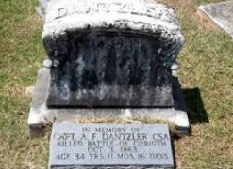On October 4, Van Dorn’s and Price’s men failed to follow up their initial victories in the previous day’s fighting, and Rosecrans mounted a successful counterattack which turned the fleeting Confederate victory into a disaster of monstrous proportion. All totaled the 37th Mississippi lost 81 men during the battle of Corinth in killed and wounded. While many would recover and fight on, the war was over for Absolom Dantzler. Back in Jasper County, his wife was left to mourn his death as a widow with several children. Of course, she joined many others with a similar fate. On December 18, the Mississippi Legislature finally filled Dantzler’s vacant seat and he was buried in the Heidelberg cemetery in Jasper County, where he remains today. Unfortunately, a memorial stone (above) erected in front of his gravestone has the incorrect date of the battle. In time, Susan Millsaps Dantzler remarried. Her first cousin, Reuben Webster Millsaps, also a Confederate veteran, went on to a successful business and banking career and later founded Millsaps College in Jackson. The controversy over the Jasper county seat apparently was never completely resolved, however, as Jasper County is one of ten counties in Mississippi with two county seats. And Absolom Fredrick Dantzler, killed 151 years ago today, is one of many thousands of Mississippians who lost their life in the bloodiest war on American soil.

Photo and Image Sources:

(1) Savage: www.findagave.com

(2) Dantzler: www.findagrave.com

(3) Flag: http://www.worthpoint.com

(4) Map: http://www.civilwar.org

(5) Grave: www.findagrave.com

\* Note: From Corinth 1862: Siege, Battle, Occupation by Timothy B. Smith. The original is in a collection at Duke University.

**http://andspeakingofwhich.blogspot.com/2013/10/perfectly-satisfied-to-die-capt-absolom\_3.html**

Special thanks to Jim Woodrick for this article. Jim publishes a blog entitled “**andspeakingofwhich**.” It is a very interesting site that brings out a lot of Mississippi history which includes incidents during the War.

We encourage all our readers to take the time to visit his blog and learn more about our state’s history.

A NOBLE CONFEDERATE SOLDIER…

THE EMBODIMENT OF SOUTHERN CHIVALRY…

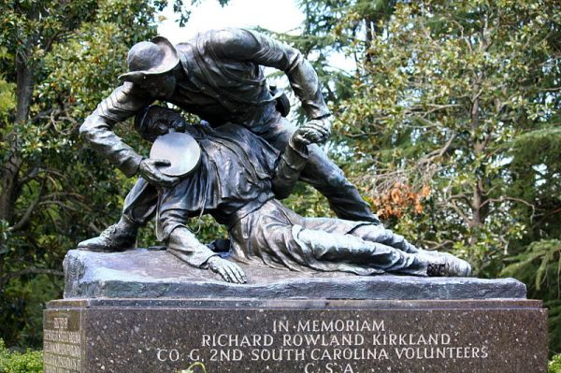

Sergeant Richard R. Kirkland 2nd South Carolina: Angel of Marye's Heights Sgt. Richard Kirkland risked almost certain death to bring water to his wounded enemies on Mayes Heights during the Battle of Fredericksburg… It is not known how many lives were saved by Sergeant Kirkland on the battlefield at Marye’s Heights that day, however Kirkland’s actions remain legendary in the war’s history and he will forever be known as the “Angel of Marye’s Heights”. As the sun rose over Marye’s Heights on the morning of the 14th the extent of the carnage was clearly visible. Wounded men lay in agony upon the field, in pools of blood surrounded by other fallen Union soldiers. Throughout the morning the moans and groans of the wounded became overwhelming to the Confederates, who had been ordered to hold the wall at the Heights. Sgt. Richard Kirkland, requested permission from his commanding officer, General Kershaw, to tend to the Union wounded, to which Kershaw approved. Kirkland gathered canteens from his fellow soldiers and leapt the stone wall onto the battlefield. For the next two hours the Confederate sergeant made his way from one wounded Union soldier to the next, tending their wounds and giving water to the destitute men. “Unarmed he reached the nearest sufferer. He knelt beside him, tenderly raised the drooping head, rested it gently upon his own noble breast, and poured the precious life-giving fluid down the fever-scorched throat. This done, he laid him tenderly down, placed his knapsack under his head, straightened out his broken limb, spread his overcoat over him, replaced his empty canteen with a full one, and turned to another sufferer.” Sergeant Richard Kirkland would continue to fight for the Confederacy, showing gallantry at Chancellorsville and Gettysburg. He met his end at the Battle of Chickamauga while leading an infantry charge up “Snodgrass Hill” on September 20, 1863.

Submitted by Peter Doré, “English Friends of the South.” This is a FB group dedicated to preserving our Southern history and has members from all over the world.